|  |
| --- |
| University of Pretoria |
| Cone Penetration Test |
| Department of Geology |
|  |
| **Sedzani Elia Muravha 28234422** |
| **2/20/2012** |

|  |
| --- |
| Abstract The cone penetration test is a type of in-situ techniques commonly used for investigating unconsolidated near surface sediments which provide continuous profiling of geostratigraphy and soil properties evaluation and to survey the subsoil in detail by logging various physical parameters in the soil during and after soil penetration to the ground. CPT can be perfume either on land or over water and requires different pushing instruments. CPT procedures requires pre-drilling, verticality, reference measurements, rate of penetration, interval of readings, dissipation tests, calibration and maintenance, pore water effects. There are different cone testing types that can be applied depending on the investigation and these cone testing types include mechanical cone testing, electric cone testing, the piezocone, the seismic cone testing. |

Contents

Abbreviations...................................................................................... 3

Introduction........................................................................................ 4

History................................................................................................ 4

Role of the CPT.................................................................................... 5

Testing equipments............................................................................ 6

Pushing equipments............................................................................. 7

* On land…………………………………………………………………. 7
* Over water………………………………………………………………. 8

Test producers...................................................................................... 8

* Pre-drilling……………………………………………………………… 9
* Verticality……………………………………………………………….. 9
* Reference Measurements…………………………………………………. 9
* Rate of Penetration……………………………………………………… 10
* Interval of readings………………………………………………………. 10
* Dissipation Tests…………………………………………………………… 10
* Calibration and Maintenance……………………………………………. 10
* Pore water effects…………………………………………………………. 10

Types of cone testing........................................................................... 11

* Mechanical cone testing………………………………………………….. 11
* Electric cone testing……………………………………………………. 11
* The piezocone……………………………………………………. 12
* The seismic cone testing…………………………………………….. 12

Additional sensors.................................................................................. 14

Cone penetration test Interpretation....................................................... 14

Application of CPT results..................................................................... 16

Conclusion............................................................................................. 17

References.............................................................................................. 18

Abbreviations

CPT = Cone penetration test.

CPTu = Cone penetration test with pore pressure measurement – piezocone test.

qc = Cone resistance.

qt = Corrected cone resistance.

Dr =Relative density

φ' = Friction angle

Ψ = State Parameter

K0 = In-situ stress ratio

E, G = Young’s and Shear moduli

G0 = Small strain shear moduli

OCR = Over consolidation ratio

M = Compressibility

su = Undrained shear strength

St = Sensitivity

ch = Coefficient of consolidation

k = Permeability

SBT = Soil Behavior Type

Introduction

The cone penetration test is one of the most popular types of in-situ technique for investigating unconsolidated, near surface sediments which provide continuous profiling of geostratigraphy and soil properties evaluation.It is used to survey the subsoil in detail by logging various physical parameters in the soil during and after soil penetration to the ground. The CPT has a variety of devices such as pore pressure CPT which is a modular, lightweight design that can be extended in length depending on the anticipated penetration. In the Cone Penetration Test (CPT), end of a cone is pushed into the ground at a constant rate and measurements of the resistance to penetration of the cone and of a surface sleeve are made continuously. The report will cover the history of CPT, test procedures, test equipments, interpretation and application of the results from the CPT.

History

The history of field cone penetrometers started around 1930 with a design by the Netherlands Department of Public Works (Mayne 2001).



Figure 1 Early Dutch mechanical cone **(**Robertson and Cabal 2009).

The figure above shows the first field cone penetrometer tests which were conducted using a 35 mm outside diameter gas pipe with a 15 mm steel inner push rod (Robertson and Cabal 2009). In the figure, a cone tip with a 10 cm2 projected area and an apex angle 60o  was attached to the steel inner push rods **(**Robertson and Cabal 2009). In 1935 the Delf Soil Mechanics Laboratory improved the CPT by designing the first operated 10 ton (100 kN) cone penetration push machine **(**Robertson and Cabal 2009).



Figure 2Dutch mechanical cone penetrometer with conical mantle **(**Robertson and Cabal 2009).

In 1948,the original Dutch mechanical cone was then improved by adding a conical partabove the cone as shown in the figure 2 above (Robertson and Cabal 2009). The purpose of the conical part or geometry was to prevent soil fromentering the gap between the casing and inner rods (Robertson and Cabal 2009).

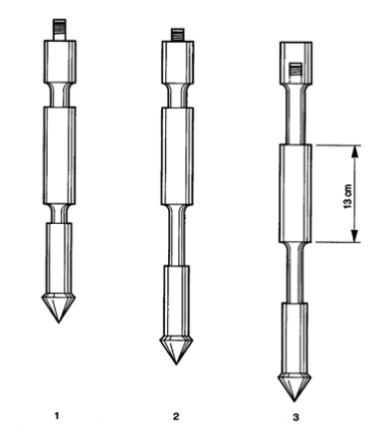

Figure 3Begemann type cone with friction sleeve (Robertson and Cabal 2009).

The CPT was again improved by adding a friction sleeve (‘adhesion jacket’) shown in figure 3 behind the cone to include the measurements of the local friction sleeve in 1953. Robertson and Cabal (2009) defined friction sleeve as “ The section of the cone penetrometer upon which the sleeve friction is measured”. Measurements were made every 8 inches (20 cm) to get the friction ratio which is used to classify soil type (Robertson and Cabal 2009). In 1965, Fugro developed an electric cone, the shape and dimensions of an electric cone formed the basis for the modern cones and the International Reference Test and ASTM procedure (Robertson and Cabal 2009).

Later around 1974 cone penetrometers were introduced, which measure the pore pressure and the measurements of pore water pressure were used to correct the cone resistance for pore water pressure effects (qt), especially in soft clay (Robertson and Cabal 2009).

Role of the CPT

The role of the CPT in any subsurface investigation is to determine the following: (Robertson and Cabal 2009).

1. Nature and sequence of the subsurface strata (geologic regime)
2. Groundwater conditions (hydrologic regime)
3. Physical and mechanical properties of the subsurface strata

Additional requirement for geo-environmental site investigation: (Robertson and Cabal 2009).

1. Distribution and composition of contaminants

|  |  |
| --- | --- |
| Advantages of CPT | Disadvantage of CPT |
| Fast and continuous profiling | High capital investment |
| Economical and productive | Requires skilled operator to run |
| Results not operator-dependent | Electronic drift, noise, and calibration |
| Strong theoretical basis in interpretation | No soil samples are obtained |
| Particularly suitable for soft soils | Unsuitable for gravel or boulder deposits |

Table 1 shows advantages and disadvantages of using CPT (Mayne 2001).

Testing equipments

There are various cone penetration test equipments that can be used on a testing site as shown in figure 4 below, most common equipments are:

1. Cone penetrometer
2. Electrodes
3. Hollow hydraulic pushing rods
4. Cable or transmission device
5. Depth recorder
6. Data acquisition unit

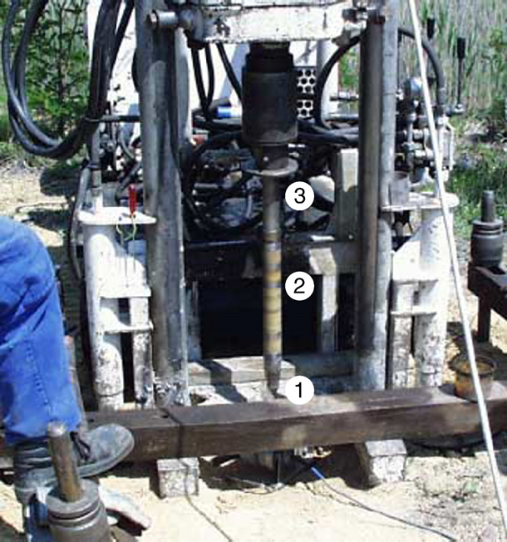

Figure 4 Cone Penetration Test (CPT) equipment used at Krauthausen test site: 1. Cone penetrometer, 2. three electrodes, 3. hollow push rods (Tillmann *at el.* 2008).

The test equipment used during CPT is the cone penetrometer. Robertson and Cabal (2009) defined a cone penetrometer as “The assembly containing the cone, friction sleeve, and any other sensors, as well as the connections to the push rods”.

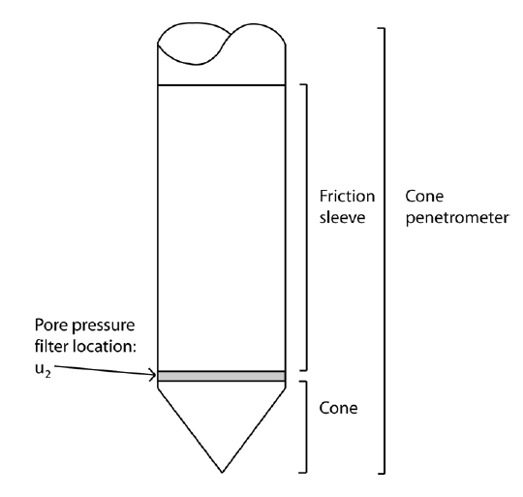

Figure 5 Cone penetrometer (Robertson and Cabal 2009).

Cone penetrometers come in a range of sizes with different probes e.g. 10 cm2 and 15 cm2 probes and are specified in most standards (Robertson and Cabal 2009). The mini CPT probes are used for shallow and inexpensive investigations, whereas the large cones can be used in gravely soils and deep investigations (Robertson and Cabal 2009).

The are different CPT devices and some are shown in the figure above, these devices are (Rahardjo 2001):

1. Cone
2. Friction sleeve
3. Pore pressure transducer for piezocone
4. Sensors
5. Rods
6. Control/measuring device

Pushing equipments

Equipment used for pushing consists of push rods, a thrust mechanism and a reaction frame and are applied in different phases e.g. Over water or on land (Robertson and Cabal 2009).

On land

Built units such as trucks or track mounted are pushing equipment commonly for land applications and CPT’s can also be carried out using an anchored drill-rig as shown in figure 6 below (Robertson and Cabal 2009).

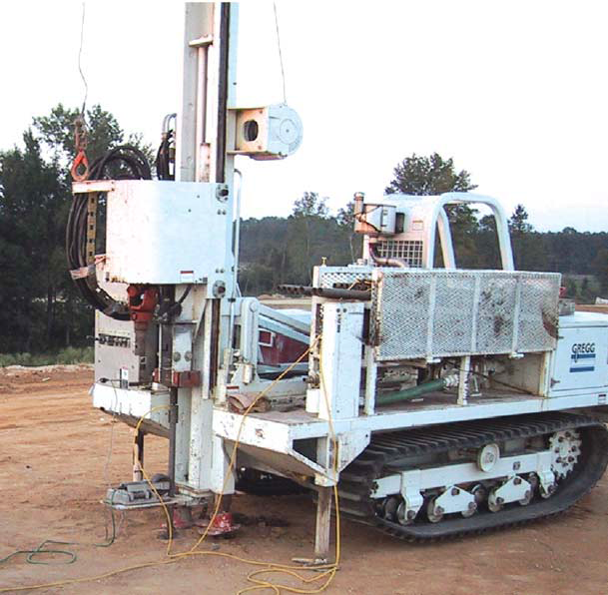

Figure 6 Small anchored drill-rig unit (Robertson and Cabal 2009).

Over water

There are different types of pushing equipment for over water investigations depending on the depth of water. Floating or Jack-up barges are pushing equipment suitable for shallow water depth (depth less than 30m/100 feet), Example in the Figure 7 below (Robertson and Cabal 2009).

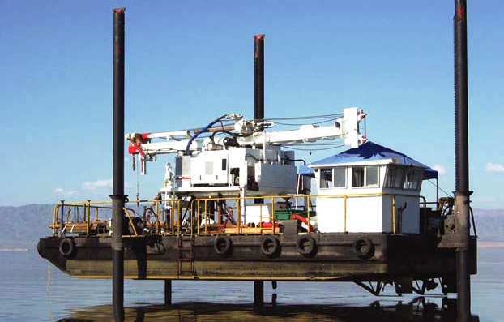

Figure 7 Mid-size jack-up boat (Robertson and Cabal 2009).

Test procedures

Figure 8 below depicts the test procedure carried out by continuous hydraulically pushing a cone into the ground at a constant speed of 20mm/s whilst measuring the tip and the shear force (Rahardjo 2001). Pore water pressure should be measured along the depth of penetration using a piezocone and readings for a dissipation test can be taken by stopping the penetration at a recorded depth e.g. every 10 to 50 mm and then measure the decay pore water pressure with time (Rahardjo 2001).

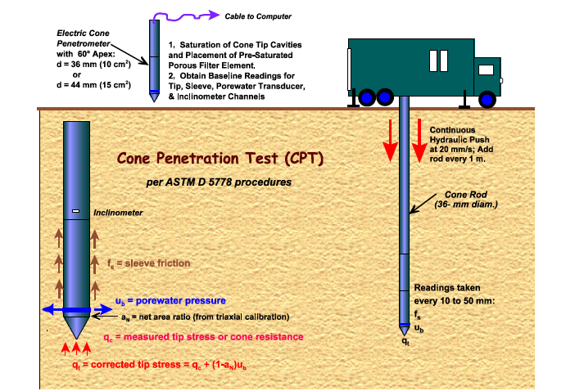

Figure 8 Procedures and Components of the Cone Penetration Test (Mayne 2001).

List of common testing procedures that are performed in CPT:

1. Pre-drilling

Performing CPT in hard soils it may be necessary to pre-drill before you penetrate the cone

in order to avoid damaging the cone (Robertson and Cabal 2009). Pre-punching a hole through the upper problem material with a solid steel dummy probe with a diameter slightly larger than the cone can be the initial stage that can also be used and it can replace pre-drilling in some cases (Robertson and Cabal 2009). It is important to first use an auger to drill 1.5m (5ft) depth in urban areas to avoid underground utilities (Robertson and Cabal 2009).

1. Verticality

The thrust machine should be set up in a level in such a way that the thrust direction is vertical or as near as possible to vertical (Robertson and Cabal 2009). The vertical thrust direction should be maintained in such a way that the deviation of the initial thrust direction from vertical should not exceed 2 degrees and push rods should be checked for straightness (Robertson and Cabal 2009). Modern cones can be able to measure non-verticality of the soundings by a use of a simple incorporated slope sensors and this helps the equipment from being damaged and breaking of push rods (Robertson and Cabal 2009). If the initial direction is vertical for depth less than 50 feet (15m) non-verticality is not common (Robertson and Cabal 2009).

1. Reference Measurements

Modern cones have been improved to have the potential for a high degree of accuracy and repeatability (0.1% of full-scale output) (Robertson and Cabal 2009). The sensors can be sensitive to the changes in temperature if the output load is zero (Robertson and Cabal 2009).

1. Rate of Penetration

The common international standard rate of penetration is 20 mm/sec (approximately 1 inch per second) (Robertson and Cabal 2009). To start and complete a 60 foot (20m) sounding it can take round about 30 minutes (Robertson and Cabal 2009). The results obtained during cone penetration are generally not sensitive to slight variations in the rate of penetration to the ground (Robertson and Cabal 2009).

1. Interval of readings

The type of data that an electric cones produce is continuous analogue data (Robertson and Cabal 2009). The analogue test is then converted by different systems to digital form at selected intervals (Robertson and Cabal 2009). The most popular standards of interval required has to be no more than 8 inches (200mm) (Robertson and Cabal 2009). In general, most standards of interval that systems collect data at is between 1 to 2 inches (25 - 50mm) and 2 inches (50 mm) is the most common interval (Robertson and Cabal 2009).

1. Dissipation Tests

The excess pore pressure generated around the cone starts to dissipate immediately when the penetration has paused (Robertson and Cabal 2009). The rate at which dissipation occurs depends on the coefficient of consolidation and the diameter of the probe, consolidation on the other hand depends on the compressibility and permeability of the soil (Robertson and Cabal 2009). Dissipation test can be performed at any depth during penetration as long as the penetration is stopped and the measurement of the decay of pore pressure in time has taken (Robertson and Cabal 2009). Dissipation tests in sand if the equilibrium pore pressures are required, the test should continue until there is no further dissipation is observed, this may take hours when dealing with plastic clays and the rate of dissipation increases with a decrease in probe size (Robertson and Cabal 2009).

1. Calibration and Maintenance

Like any other equipments calibrations should be done at regular intervals (approximately every 3 months) (Robertson and Cabal 2009). The better way to maintain the equipments and get best results for major projects, is to make show that calibration is done before and after field work, with functional checks during the work (Robertson and Cabal 2009).

1. Pore water effects

In soft clays and silts and in over water work, the measured cone resistance (qc) defined by Robertson and Cabal (2009) as “the force acting on the cone, Qc, divided by the projected area of the cone, Ac” must be corrected for pore water pressures acting on the cone geometry, to obtaining the corrected cone resistance (qt) which is given by the equation below (Robertson and Cabal 2009):

qt = qc + u2 (1 – a)

Where ‘a’ in the equation is the net area ratio that can be determined from laboratory calibration with a typical value between 0.70 and 0.85 (Robertson and Cabal 2009). When dealing with sandy soils qc = qt (Robertson and Cabal 2009).

Types of cone testing

There are different cone testing types, namely:

1. Mechanical cone testing
2. Electric cone testing
3. The piezocone
4. The seismic cone testing

Mechanical cone testing

The mechanical cone testing for Delft cone has a certain procedure to be followed during testing performance (Clayton 1995).

1. The cone end has to be advanced by 8cm, a string of solid 15 mm diameter rods which extend inside the outer hollow rods from the cone to the ground surface should be pushed down at the ground surface (Clayton 1995).

2. Measure the cone resistance at the ground surface using a hydraulic load cell connected to a pressure gauge, or with an electrical transducer, positioned at the top of the rod string, while the cone is moving at the standard rate to the ground surface (Clayton 1995).

3. After measuring the cone resistance, push the outer rods downwards by 20 cm while the cone rod moving together (Clayton 1995).

4. Redo the entire process until you get the intermittent force measurements at 20cm depth intervals (Clayton 1995).

5. Make sure that in every meter of each measurement you add new inner and outer rods (Clayton 1995).

Electric cone testing

Electric cones are more advanced and expensive, because the their cone manufacture and data logging and recording (Clayton 1995). In the electric cone testing, cone resistance is measured as standard, and sides of the penetrometer measure the friction (Clayton 1995). A fully manufactured CPT with many features can measure: (Clayton 1995).

1. cone inclination, to check that the cone is not drifting out of vertical;

2. pore pressure (in the ‘piezocone’);

3. soil resistivity (used, for example, in pollution studies);

4. ground vibration, using three-component geophones (in the ‘seismic cone’);

5. gamma-ray backscatter (for density determination);

6. pressure meter values (see later); and

7. sound (the ‘acoustic’ penetrometer).

Lists the advantages of the electric penetrometer include (Clayton 1995):

1. improved accuracy and repeatability of results, particularly in weak soils;

2. better delineation of thin strata (because readings can be taken more frequently);

3. faster over-all speed of operation;

4. the possibility of extending the range of sensors in or above the tip (see above); and

5. more manageable data handling.

The piezocone

Mayne (2001) defined piezocone as the “cone penetrometers with added transducers to measure penetration pore water pressures during the advancement of the probe”.

The different major applications of the piezocone testing in different conditions are as follows :

1. *Profiling*. The piezocone comprises of a thin pore-pressure-measuring element which detects the presence of thin granular layers within soft cohesive deposits and these layers are of great importance to consolidation rate of soft clay deposit (Clayton 1995).

2. *Identification of soil type*. The soil type can be manipulated by the use of a ratio between excess pore pressure and net cone resistance (Clayton 1995).

1. *Determining static pore pressure*. Whenever the dissipation is rapid in granular soil type, measurements of the static pore pressure can be made and estimations can be made in clay (Clayton 1995). When rods addition to cone has stopped or full dissipation of excess pore pressure set up by penetration has been waited, the estimation can be made in clay (Clayton 1995).
2. *Determination of in situ consolidation characteristics*. In clays, stopping the cone and measuring pore pressure dissipation as a function of time can determine the horizontal coefficient of consolidation, c, (Clayton 1995).

The seismic cone testing

The Seismic Cone Penetration Test (SCPT) is a CPT type commonly used to determine the variation with depth of the shear and longitudinal wave velocity at various sites in the ground (Karl at el. 2006).

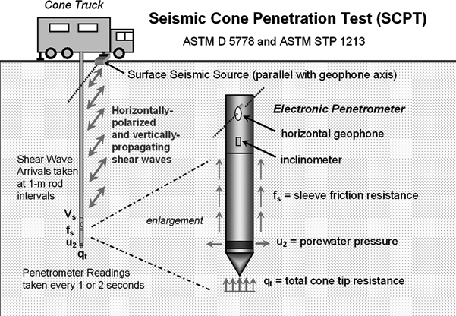

Figure 9 Setup and procedure for pseudo-interval seismic cone penetration testing (SCPT) (Mayne 2007).

Most seismic cones contain either one or two and even three-component geophone arrays, mounted internally, some distance behind the friction sleeve and in figure 9 above there is a horizontal geophone mounted in the electric penetrometer (Clayton 1995). Where two component geophone arrays are used, the vertical distance between the arrays will be of the order of 1 m, or more during the test performance (Clayton 1995). A seismic cone has been proved to be a tool for determining the benchmark value of very small strain stiffness (G0) (Clayton 1995).

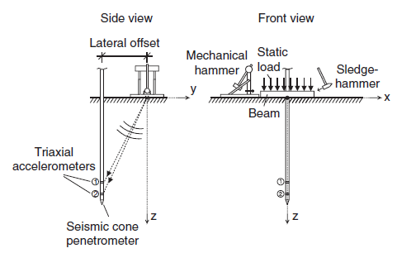

Figure 10 Side view and front view of the SCPT setup using a dual cone (Karl at el. 2006).

From the side view figure above cone is pushed into the soil with a pushing equipment and two triaxial accelerometers namely 1 and 2 from the side view figure are installed in the cone’s housing with a distance between them of approximately 1m (Karl at el. 2006). The accelerometers have flat frequency response over the whole frequency range of interest, this makes them to be very useful (Karl at el. 2006). The frequency range of a commonly used miniature geophones has a range that fall inside the flat frequency response range and are therefore not suitable for an accurate measurement of the response (Karl at el. 2006). The source of seismic waves comprises of a steel beam with a conventional sledgehammer or a mechanical swing hammer as shown in the figures above, with adjustable falling height to generate a vertically propagating shear wave in the soil (Karl at el. 2006).

Additional sensors

The CPT has been developing since the first field cone penetrometers in 1930. The introduction of the electric cone in the early 1960’s lead to the development of CPT into different additional sensors being added to the cone, such as (Robertson and Cabal 2009);

* Temperature
* Geophones (seismic wave velocity)
* Pressure meter
* Camera (visible light)
* Radioisotope (gamma/neutron)
* Electrical resistivity/conductivity
* Dielectric
* pH
* Oxygen exchange (redox)
* Laser/ultraviolet induced fluorescence (LIF)
* Membrane interface probe (MIP)

The latter sensors development are primarily for geo-environmental applications, where they use geophone to allow the measurement of seismic wave velocities (Robertson and Cabal 2009).

Cone penetration test Interpretation

The applicability to estimate soil parameters varies because the CPT has different sensors e.g. pore pressure -CPTu and seismic –SCPT and this also cause numerous semi-impirical correlations to vary in their reliability and applicability (Robertson and Cabal 2009).

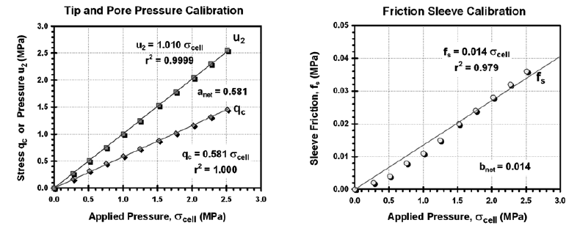

Figure 11 Cone calibration results in pressurized triaxial chamber for net area ratio determination (Mayne 2007).

Figure 11 shows calibration results of a brand new cone penetrometer in a triaxial pressurized chamber for three readings (Mayne 2007). A straight best fit line from the figures shows that the pore water pressure transducer is directly proportional to the applied chambers pressures which indicate excellent response (Mayne 2007). The cone tip resistance shows less response because is uncorrected (Mayne 2007).

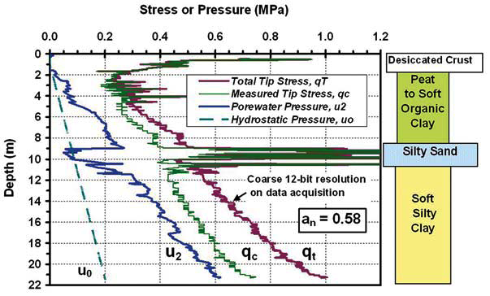

Figure 12 Example CPTu sounding showing uncorrected and corrected cone tip resistances (Mayne 2007).

Figure 12 depicts the results obtained from the use of same penetrometer in soft sediments of New Orleans (Mayne 2007). The soil profile of investigated area is shown in the figure 12 above, which consist of desiccated crust overlying peat to soft organic clay, approximately 2 m deep layer of loose silty sand underlain by a layer of soft silty clay that extend to a depth of 22 m. In the figure one can directly compare raw measured tip stress to corrected tip stress (Mayne 2007).

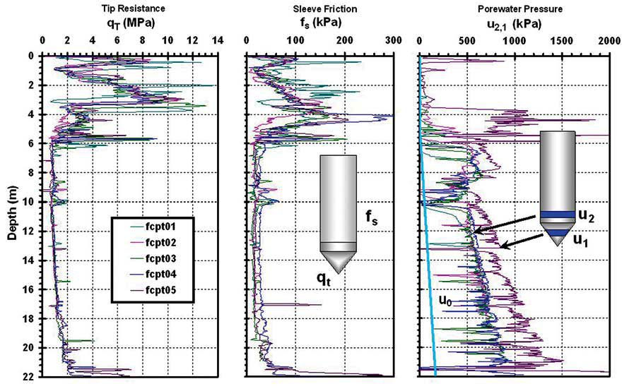

Figure 13 Series of piezocone penetration tests at Northwestern University (Mayne 2007).

Figure 13 represent a series of five CPTu, shows the total cone resistance, sleeve friction and pore water pressure readings (Mayne 2007). This tests were made in near the national geotechnical experimentation site at Northwestern University in Evanston, Illinois, where the silty clay deposits is overlain by a layer of sandy fill with the thickness of 4 m (Mayne 2007).

There are three major areas of cone design that influence interpretation of the results (Rahardjo 2001).

1. Unequal area effects
2. Piezometer location, size and saturation
3. Accuracy of measurement

Application of CPT results

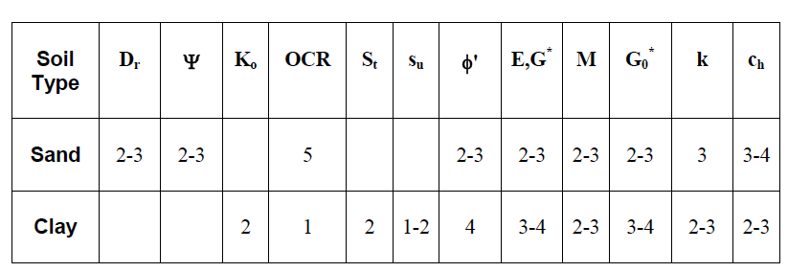

Table 2 Perceived applicability of CPTu for deriving soil parameters (Robertson and Cabal 2009).

From the table above: 1=high, 2=high to moderate, 3=moderate, 4=moderate to low, 5=low reliability, Blank=no applicability.

Where:

Dr Relative density φ' Friction angle

Ψ State Parameter K0 In-situ stress ratio

E, G Young’s and Shear moduli G0 Small strain shear moduli

OCR Over consolidation ratio M Compressibility

Su Undrained shear strength St Sensitivity

Ch Coefficient of consolidation k Permeability

Table 2 above shows the estimation of soil parameters by an estimation of the perceived applicability of CPTu and the ability to estimate soil stiffness (E,G and Go) can further be improved if the seismic is added (Robertson and Cabal 2009).

Parameters measured by CPT are (Rahardjo 2001):

1. Tip resistance, qc (kg/cm2)
2. Friction resistance, fs (kg/cm2)
3. Pore pressure, u (for piezocone)

Factors affecting the results summarised by Rahardjo (2001):

1. Type and consistency or density of soils
2. Confining pressure or overburden pressure
3. Verticality
4. Rate of penetration
5. Calibration of sensors
6. Wear of the cone
7. Temperature changes
8. A rigid pore pressure measuring system and a fully saturated system for piezocone
9. Rate of dissipation of pore pressures for piezocone
10. Location of the filter and axial load on the cone for piezocone
11. Variations in the test apparatus

Conclusion

The cone penetration test is a type of in-situ techniques commonly used for investigating unconsolidated near surface sediments which provide continuous profiling of geostratigraphy and soil properties evaluation and to survey the subsoil in detail by logging various physical parameters in the soil during and after soil penetration to the ground. The role of the CPT in any subsurface investigation is to determine the nature and sequence of the subsurface strata (geologic regime), groundwater conditions, physical and mechanical properties of the subsurface strata, distribution and composition of contaminants.There are different cone testing types that can be applied depending on the investigation and these cone testing types include mechanical cone testing, electric cone testing, the piezocone, the seismic cone testing. Interpretation and application processes using of results obtained from the site can be done by a graphic results of different pressures at depth.

References

1. Clayton C.R.I., Matthews, M.C. and Simons, N.E. (1995). Site investigation: *In situ* testing. Department of Civil Engineering, University of Surrey. Second Edition. [Available online:] <http://www.geotechnique.info/>
2. Karl, L. Haegeman, W. and Degrande G. (2006) . Determination of the material damping ratio and the shear wave velocity with the Seismic Cone Penetration Test. *Soil Dynamics and Earthquake Engineering*. 26: 1111–1126
3. Kopf, A., Stegmann, S., Delisle, G., Panahi, B., Aliyev, C.S. and Guliyev, I. (2009) .In situ cone penetration tests at the active Dashgil mud volcano, Azerbaijan: Evidence for excess fluid pressure, updoming, and possible future violent eruption. *Marine and Petroleum Geology*. 26: 1716–1723
4. Mayne, P.W. (2007). NCHRP SYNTHESIS 368 Cone Penetration Testing: A Synthesis of Highway Practice National cooperative highway research program: Washington, DC. -126pp
5. Mayne, P.W., Barry, R., and DeJong, J. (2001). Manual on Subsurface Investigations**:** Geotechnical Site Characterization.National Highway Institute**.** Washington DC. -304pp
6. Rahardjo, P.P. (2001). In situ Testings and Soil Properties Correlation. Geotechnics Laboratory. Bandung. -135pp
7. Robertson, P. K. And Cabal K.L. (2009). Guide to Cone Penetration Testing for Geotechnical Engineering. 3rd Edition.Gregg Drilling & Testing, Inc. Signal Hill. -134pp
8. Tillmann, A., Englert, A., Nyari, Z., Fejes, I., Vanderborght J. and Vereecken H. (2008). Characterization of subsoil heterogeneity, estimation of grain size distribution and hydraulic conductivity at the Krauthausen test site using Cone Penetration Test. *Journal of Contaminant Hydrology.* 95: 57–75