university of pretoria
Discuss the purpose of engineering geological mapping and indicate which aspects should appear on an engineering geological map.
The Department of Geology
Sedzani Elia Muravha 28234422
2/20/2012

Abstract Engineering geological maps produce a representation of different features of geological and geotechnical environmental significance in land use and design, construction, development of civil and mining works. Engineering geological maps have been for many years in the storage of geological, geotechnical and engineering information. There are different types of engineering geological maps for foundation areas and excavations, rock Slopes, Major Outcrops and water tables, expansive soils, transported or deposited soils, residual soils, hazard maps, tunnel maps, mine maps, nature Cavities, etc. The aspects in the engineering geological gives detailed and useful information in engineering geology.

Contents

Introduction……………………………………………………………… 3
Engineering geological mapping objectives and techniques or methodology 3

- Objective ……………………………………………………………………… 3
- Methodology and techniques of mapping……………………………………… 3

Engineering geological maps…………………………………………… 5

- Engineering geological mapping production…………………………………… 5

Aspects on an engineering geological maps……………………………… 6

- Mapping at a small scale………………………………………………………… 11
- Mapping at a large scale………………………………………………………… 11

- Foundation Areas and Excavations……………………………………… 11
- Rock Slopes, Major Outcrops and water tables………………………… 12
- Expansive soils………………………………………………………… 13
- Transported or deposited soils………………………………………… 14
- Residual soils……………………………………………………………… 15
- Hazard maps……………………………………………………………… 15
- Tunnel maps……………………………………………………………… 16
- Mine maps……………………………………………………………… 16
- Nature Cavities…………………………………………………………… 16

Conclusion………………………………………………………………… 16
References………………………………………………………………… 16

Introduction

Engineering geological maps are very useful tools for information storage about terrains, development planning of civil and mining works, presenting spatial distribution and mechanical properties. Engineering geological maps can be defined as a type of geological map that gives a representation of all components of geological and geotechnical environmental significance in land use and design, construction, development of civil and mining works. The main focus of the report is to elaborate on the purpose of engineering geological mapping and their aspects on the map, the map scales and mapping techniques are thus important in engineering geological mapping.

Engineering geological mapping objectives and techniques or methodology

Objective

High resolution, commonly of 1:10 000 scale mapping is the main objectives in engineering geological mapping to portray all constraints or geohazards that can affect human race and their properties (Richards 2006).

Methodology and techniques of mapping

The methodology of engineering geological mapping of this report will be base on techniques done during the compilation of Pietermaritzburg engineering geological map in South African by Richards (2006). The compilation of data into a 1:50 000 engineering geological map involved three different stage processes, namely gathering and review of data, mapping into details using aerial photographs and 1:10 000 orthophoto maps (Richards 2006). There were different underlying assumptions that were made, like, landform type should relate the geotechnical properties and these properties are influenced by bedrock type together with the nature of the weathering products (Richards 2006). The regolith can occur as in situ soils or transported sediments on a range of slope gradient along with the bedrock due to the weathering processes (Richards 2006). The relation of landform type with geotechnical properties was characterized by analysis of representation samples from each landform and then presented on the map sheet (Richards 2006). There were six geotechnical factors in which all the landforms were assessed and these factors are tabulated below in Table 1 and other sub-critical factors not tabulated but used during mapping were, collapsing or settling, permeability of soil, poorly consolidated soil, dispersive soil and acidic soil and these factors does not impose major constraints to development in the mapping area (Richards 2006). The soil profile which were geotchnically and pedologically described and checked, and the laboratory analyses were gathered from presently existing geotechnical database (Richards 2006). The samples taken from different landforms in the map sheet area were analyzed in the laboratory where different tests such as the Atterberg limits and linear shrinkage were performed (Richards 2006). In the laboratory, other parameters were measured including the percentage clay fraction of a sample, grading modulus, degree of potential expansiveness, and the soil was classified (Richards 2006). The interpretation of regolith profiles, laboratory results, geological, hydrological, hydrogeological, slope and topocadastral data to produce a 1:50 000 engineering geological map was a final stage of mapping (Richards 2006).
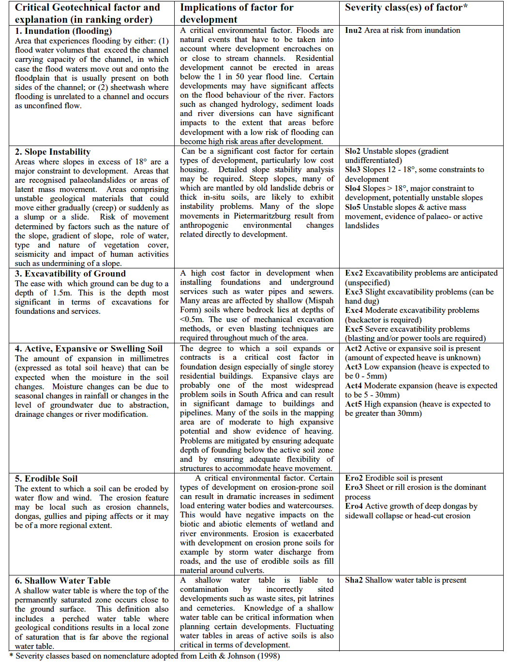
Table 1 Listing of critical geotechnical factors mapped in engineering geology (Richards 2006)

Engineering geological maps

An engineering geological map production requires different systematic searches for sources of information such as literature survey, aerial photographs and imagery, fieldwork, etc (Bell 1998). Useful information from site investigation reports, records of present and past mining activity and topographical maps are also required to prepare an engineering geological map (Bell 1998). The amount of data present and the way in which the data is presented in the engineering geological map defines its scale (Bell 1998). There are different scales in which engineering maps are produced, the most common scale is 1:10 000 or smaller (Bell 1998). An engineering geological map is a simplified model of geological facts and aspects that cannot be portrayed to its entirety because of the complexity of various geological factors (Bell 1998). The simplification of portraying various geological factors requires larger scale of the map and relationship of these geological factors, the accuracy of the data and presentation techniques (Bell 1998). Portrayed information should be necessary to evaluate the engineering geological features such as the engineering properties of the soil, engineering geological characteristics of the underlying bedrock (Maharaja 1995). Underlying bedrock characteristics that should be mapped include the geologic structure, lithology and composition, mineralogy, texture, colour, degree of weathering, alteration, etc (Maharaja 1995). All the information that has been collected during a survey, cross section, explanatory text should be represented in the engineering geological maps (Bell 1998).

Engineering geological mapping production

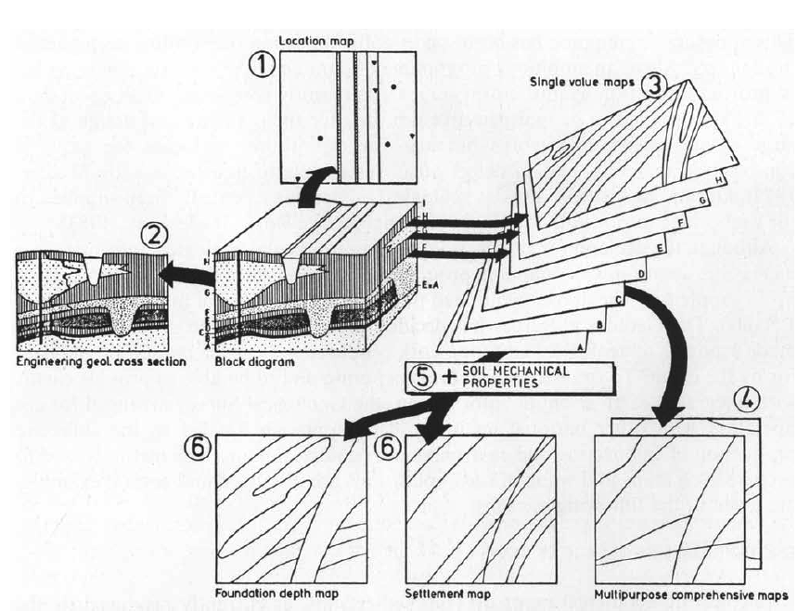
Figure 1 Simplified scheme for the production of engineering geological maps. (De Mulder and Hillen 1990).
In the Netherlands, engineering geological maps are produced by the Geological Survey and Delft Geotechnics. These maps produced are large scale maps which provide data on the borehole logging systems, cone penetration test result of different landforms, geophysical as well as geotechnical studies (De Mulder and Hillen 1990). Engineering geological map production requires a compilation of different maps and cross-sections with special engineering geological features, these maps include the location maps, geotechnical cross-section, multipurpose comprehensive maps, and special-purpose maps as illustrated in figure 1 above (De Mulder and Hillen 1990). Figure 1 portray a simplified scheme for engineering geological map production with different steps of production, namely:

- Location map. The results to be presented on the location maps are all geological, geophysical, geotechnical, geohydrological, geochemical data that are currently present (De Mulder and Hillen 1990).
- Engineering geological cross-section. To produce a detailed engineering geological map, preparation of various cross-sections of propose geology or landform and soil profile will be significant (De Mulder and Hillen 1990).
- Single value maps. Single value maps are types of maps indicating and preparing standardized interpretation of data about the depth and thickness of layers in a soil profile (De Mulder and Hillen 1990).
- Multipurpose comprehensive maps. These maps only portray the soil profile, thickness, depth of individual layers (De Mulder and Hillen 1990)
- Soil mechanical properties. The geotechnical, hydrogeological and geochemical properties of different soil layers are characterized here (De Mulder and Hillen 1990).
- Foundation depth and settlement maps. This is a final step in map production for preparation of special-purpose maps such as settlement- depth maps, industrial aggregate maps, hydrological maps and environmental geological maps, etc (De Mulder and Hillen 1990).

Aspects on an engineering geological map

The main purpose engineering geological maps is to provide detailed information on different engineering geological aspect such as the grade of weathering, joint patterns, mass permeability, foundation conditions as shown in an engineering geological map figure 2 below (Bell 1998). Engineering purposes information as well as various other aspects of engineering geology are covered on the multipurpose maps (Bell 1998). Bell (1998) noted that engineering geological maps can either be analytical or comprehensive. Analytical maps gives detailed information on individual components of particular geological environment, for example, detailed maps of seismic hazard or map showing the degree of weathering (Bell 1998). Comprehensive maps are maps of engineering geological zoning which provide all principal components of engineering geological environment (Bell 1998).

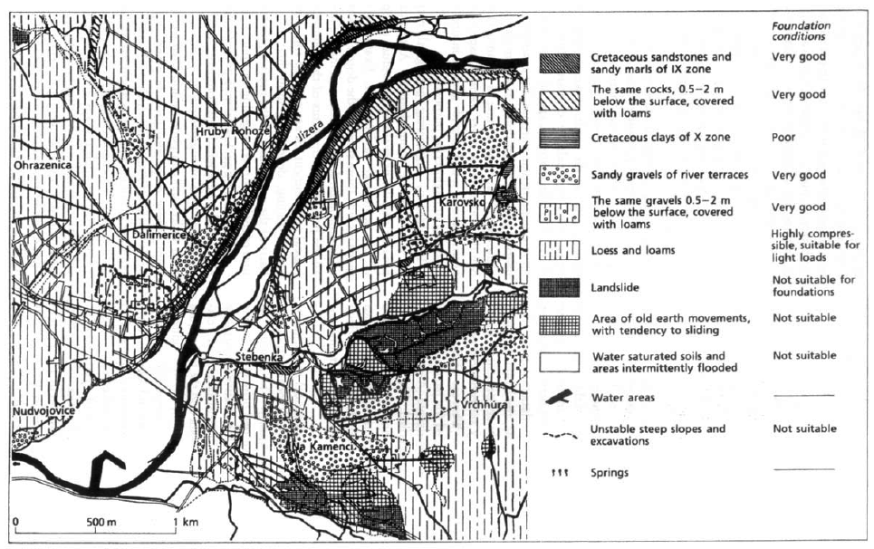
Figure 2 Engineering geological map of Turnov (Bell 1998).

Figure 2 provides simplified geological environment, range and types of engineering geological conditions, individual components and their relationships (Bell 1998). Engineering geological map shown in figure 2 above also helps in land-use planning and location, construction and maintenance of engineering structure (Bell 1998). Engineering geological map can be derived from a geological map that has been add engineering geological data and if the data is extensive, it can be represented in tabular form as show in figure 3 and table 2(a) and (b) (Bell 1998). Figure 3 illustrate on different aspects that should appear on an engineering geological map. Different aspects such as superficial deposits and bedrock presented on the map should be described into details and rocks together with soil should be classified in terms of their engineering geological behavior (Bell 1998). Other aspects are geological structures that has been recorded, for example, faults and shear zones, or any type of discontinuities and grade of weathering (Bell 1998). Unit boundaries and stratigraphical boundaries should be drawn for the change in the engineering geological properties (Bell 1998). The only disadvantage of engineering geological map is the properties of rocks and soil change through time, therefore regular visit of the site and in situ testing of the sample from the site will be needful for the production of map based on engineering geological properties (Bell 1998).

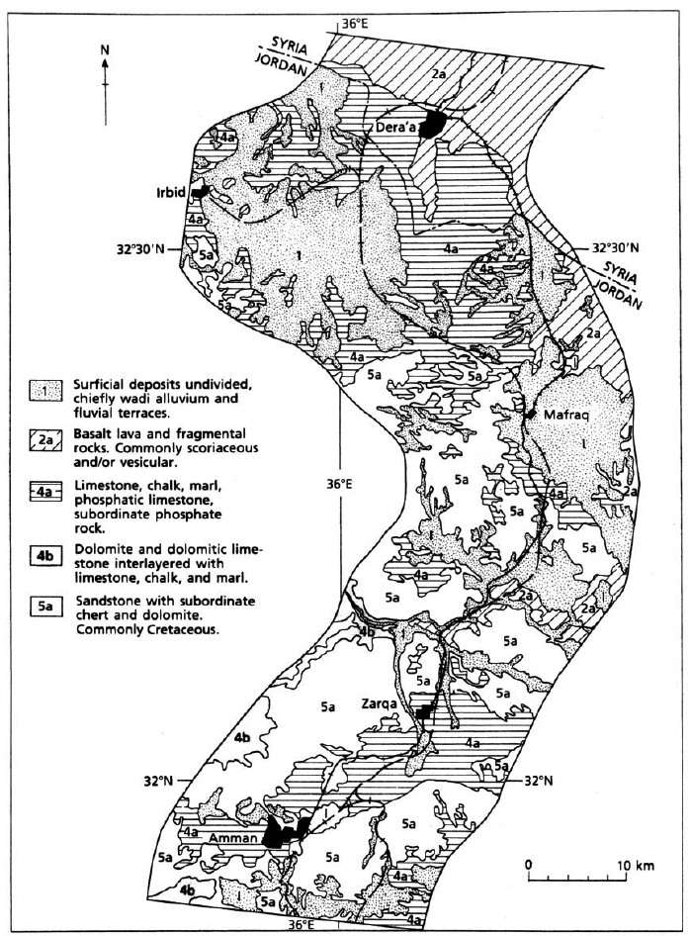Figure 3 Segment of the engineering geological map for the Hijaz railway in Jordan (Bell 1998).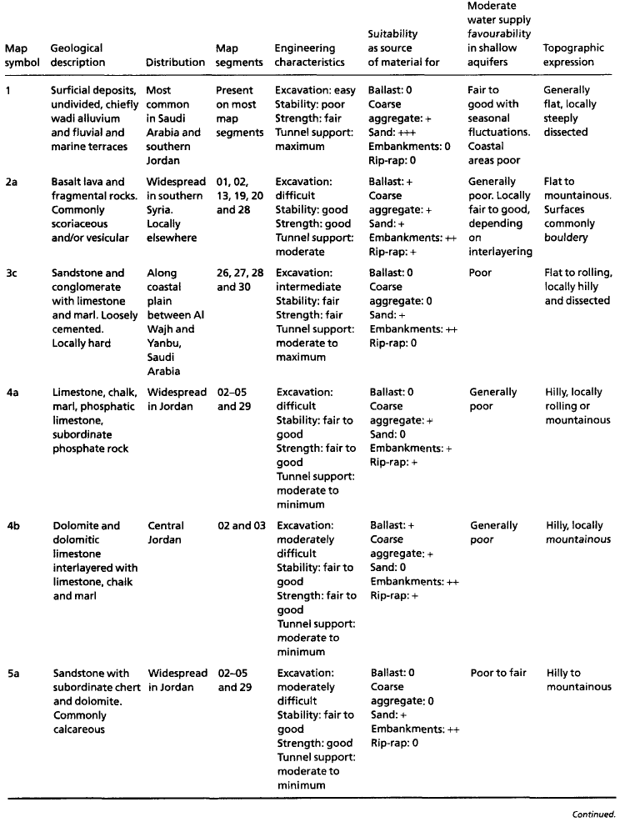
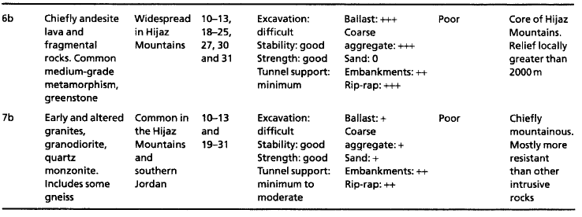
Table 2(a) Illustrate the variety of materials in the study area for the Hijaz railway (Bell 1998)

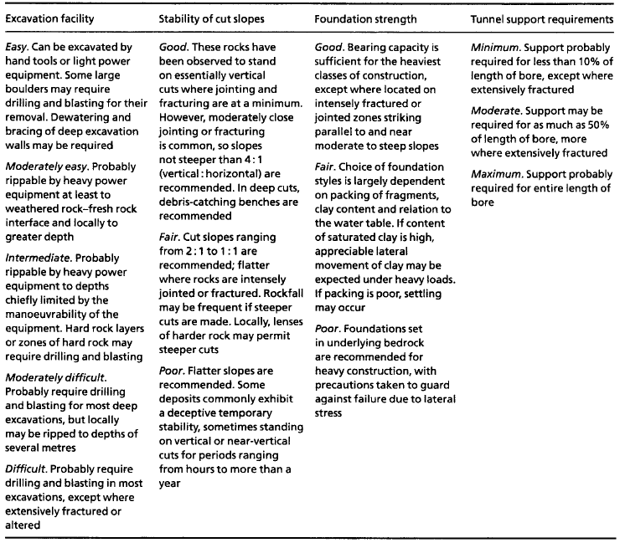Table 2(b) Key to the engineering characteristics column of the engineering geology table (Table 2(a)) (Bell 1998).
Most engineering geological aspects that appears on an engineering geological maps can be presented either small scale maps or large scale maps depending on the complexity and mapped areas.

Mapping at a small scale

Engineering geological mapping on a scale greater than 1:5 000 may be considered small scale mapping (Price 2009). Mapping at a small scale are commonly useful for roads and tunnel locations, location of construction materials, small scale hazards, description of geological condition of areas (Price 2009).

Mapping at a large scale

Large scale maps provide detailed information of different aspects of relatively small surface area, with scale range of about 1:1 000 (for engineering geological dam sites) to 1:50 (for a rock slope or tunnel) (Price 2009). Different aspects and large scale engineering geological maps illustrating aspects that are represented on a large scale engineering geological maps are provided below.

- Foundation Areas and Excavations

Largest map scaling is that of a proposed dam site in foundation areas and excavations (Price 2009). Here accurately mapped details of engineering geological boundaries and discontinuities are required to establish boundary and outcrop location with the use of standard survey techniques (Price 2009). A good maps should information about borehole and outcrops, preferably in three-dimension and they should contain a grid reference system and elevation of stable site benchmark (Price 2009). In terms of foundation data portrayed should fulfill the rock mass classification system requirement and the location of major discontinuities should be accurately plotted as show in the figure 4 below (Price 2009).
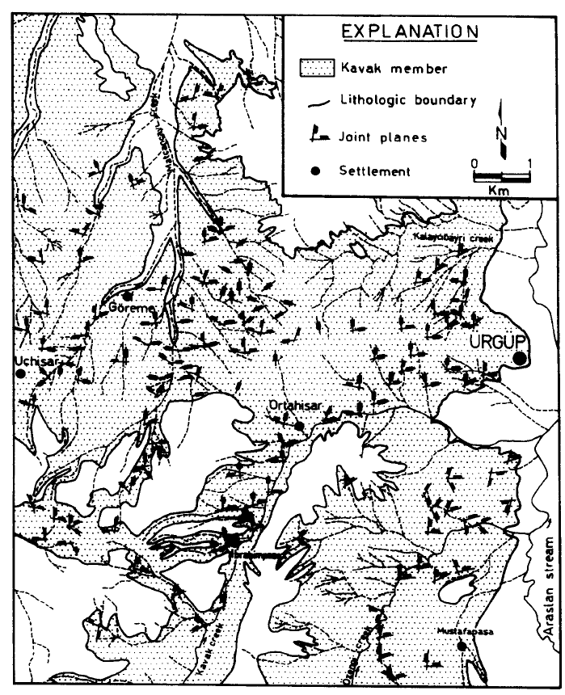
Figure 4 Map showing the distribution of joints in the Cappadocian tuff (Topal and Doyuran 1997).
- Rock Slopes, Major Outcrops and water tables

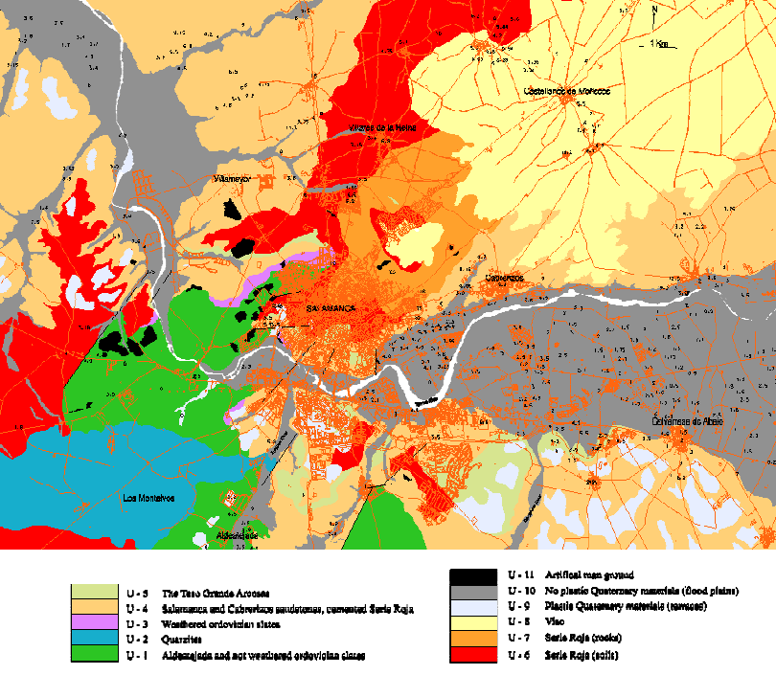

Figure 5 Engineering geological map for the urban area of Salamanca. Numbers represent the position of the water table from the surface. (Nespereira et al. 2006)

Units represented on the engineering geological map (figure 5) are:
U-1 Aldeatejada and unweathered Ordovician slates
U-2: Quartzites
U-3: Weathered Ordovician slates
U-4: Salamanca and Cabrerizos sandstones
U-5: Teso Grande Arkosic Unit
U-6: Rock materials from the Serie Roja (carbonated and not carbonated)
U-7: Serie Roja, soils.
U-8: Viso
U-9: Plastic Quaternary deposits
U-10: No plastic Quaternary deposits
U-11: Artificial and manmade ground.

- Expansive soils

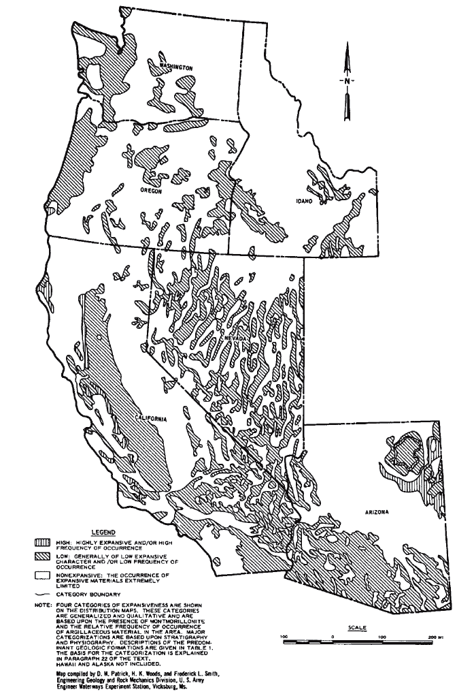
Figure 6 Distribution of potentially expansive materials in the United States: FHWA Regions 9 and 10. (Unknown Authors 1988)

Expansive soil is one of the important aspects that are present in the engineering geological maps which gives a detailed information of types of expansive soils e.g. highly expansive, low expansive or non-expansive soils as illustrated on the figure above.

- Transported or deposited soils

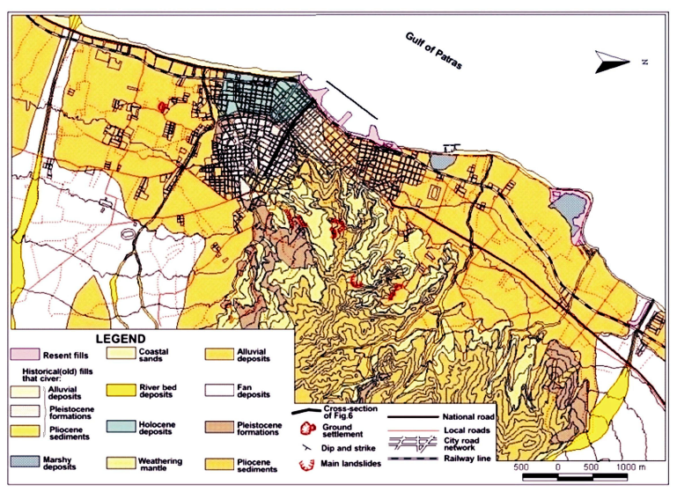
Figure 7 The engineering geological map of Patras city metropolitan area (Rozos et al. 2006)

There are different types of deposited soils that can be illustrated in an engineering geological map and these soils include alluvial deposits, fan deposits, Holocene deposits, river bed deposits, marshy deposits, etc. The figure above, provided other engineering geological features such as ground settlement, landslides, main landslides and these features gives useful information on the engineering behavior of soil and types of foundation to be constructed.

- Residual soils

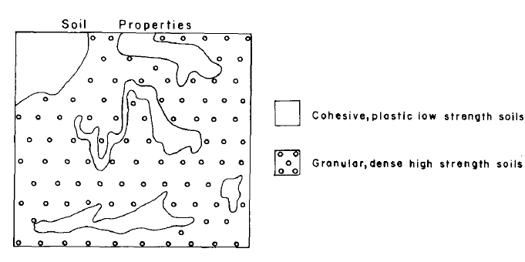
Figure 8 Idealized example of engineering geological mapping of residual soils. (Malomo et al. 1983)

Engineering geological map of residual soils commonly gives information on the structure of the soil, engineering properties of residual soils as illustrated in figure 8 above.

Other engineering geological maps with more aspects are:
- Hazard maps
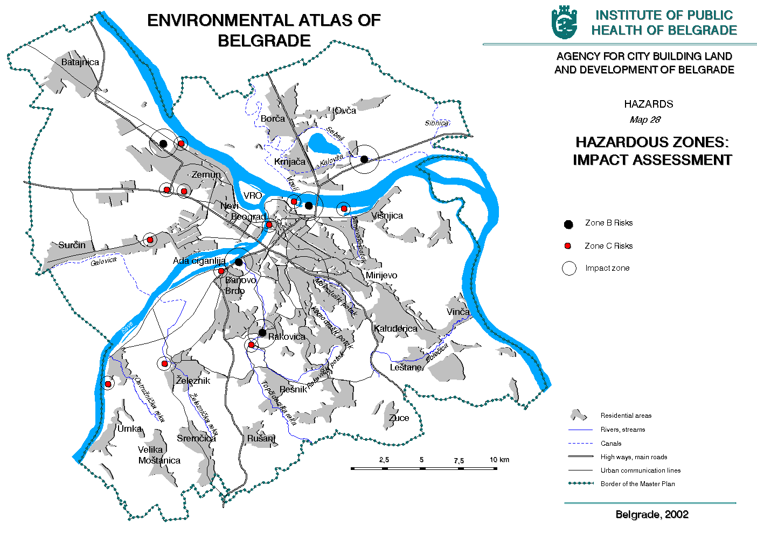
Figure 9 shows a hazard map (Institution of public health of Belgrade 2002).

- Tunnel maps
- Mine maps
- Nature Cavities

Conclusion

The purpose of engineering geological mapping is to provide detailed information on different engineering geological conditions and features such as the grade of weathering, joint patterns, mass permeability, foundation conditions, soil types, tunnels, mines, excavation. Engineering geological maps are type of geological map that gives a representation of all components of geological and geotechnical characteristics of rocks, soil, water and other feature for significance land use and design, construction, development of civil and mining works. To produce detailed and reliable engineering geological map, different aspects such as expansive soils, measured joints, faults, residual soils, transported soils, geology of the location, rock slopes, outcrops, underlying bedrock, foundations, excavations, geologic structure, lithology and composition, mineralogy, texture, colour, degree of weathering, alteration, etc.

References

- Bell, F.G. (1998). Environmental Geology: Principles and Practice. Blackwell Science Ltd. United Kingdom. Pp. 23-33
- De Mulder, E.F.J. and Hillen, R. (1990). Preparation and application of engineering and environmental geological maps in The Netherlands. Elsevier Science Publishers B.V. Amsterdam. 29: 279-290
- Institution of public health of Belgrade. (2002). Environmental atlas of Belgrade. Agency for city building land and development of Belgrade. Belgrade.
- Maharaja, R.J. (1995). Engineering-geological mapping of tropical soils for land-use planning and geotechnical purposes: A case study from Jamaica, West Indies. Place unknown. Publisher unknown. 40: 243-286
- Malomo, S., Olorunniwo, M.A. and Ogunsanwo, O. (1983). Engineering geological mapping in terrains of tropical weathering—An example from Abuja, Nigeria. Elsevier Science Publishers B.V. Amsterdam. 19: 133—148
- Nespereira, J.J., Yenes, O.M., Charfole, J.F. and Sanchez, F.J. (2006). Engineering geological mapping for the urban area of Salamanca (Spain). IAEG2006 Paper number 315. The Geological Society of London. Place unknown. Pp.1-9
- Price, D.G. (2009). Engineering Geology: Principles and Practice. Springer. Verlag Berlin Heidelberg. Pp. 1-460
- Richards, P.N. (2006). Engineering geological mapping in Pietermaritzburg, South Africa: Constraints on development. Council for Geoscience. South Africa. Pp. 1-11
- Rozos, D., Koukis, G. and Sabatakakis, N. (2006). Large-scale engineering geological map of the Patras city wider area, Greece. IAEG2006 Paper number 241. The Geological Society of London. Place unknown. Pp.1-11
- Topal, T. and Doyuran, V. (1997). Engineering geological properties and durability assessment of the Cappadocian tuff. Department of Geological Engineering. Turkey. 47: 175-187
- Unknown Authors. (1988). Manual on subsurface investigations: Chapter 5.0 Geological constraints. American Association of State Highway and Transportation Officials, Inc. Washington, D.C. pp. 49-81.

